“ARDUINO MIDI TRUMPET”

NYCCT MTEC 2280 FINAL PROJECT

TERRY CHUN

Last revised 12/11/2020

**Table of Contents**

INTRODUCTION 3

PROJECT DESCRIPTION 3

PARTS LIST 6

BUILD PROCESS 7

CONCLUSION 13

APPENDICES 15

APPENDIX A: INITIAL DRAWING 15

APPENDIX B: MODEL DRAWING 15

APPENDIX C: MIDI TRUMPET SCHEMATIC 16

APPENDIX D: MIDI TRUMPET WIRING DIAGRAM 16

**Introduction**

In spite of the growing popularity of MIDI instruments, there is relatively a lack of development for woodwind and brass MIDI instruments. There are many sensitive elements that are technically challenging in translating the playing of woodwind and brass instrument to MIDI language.

This project aims to create a MIDI trumpet at the most basic level with 11 note range capability using Arduino and Processing.

The project, for educational purposes, explores the idea of using PVC pipes and mechanical switches to create an electric trumpet and explores the MIDI capabilities of Processing while establishing serial communication with Arduino.

**Project Description**

The Arduino MIDI trumpet is mainly comprised of two parts: lead pipe with two roller switches that activate with air breathed into the mouthpiece, and three valves with push buttons that act as fingering keys.

A long plastic bag runs through the lead pipe and opens to the mouthpiece of the instrument. As the player blows air into the mouthpiece, the bag inflates and will either activate the first roller switch close to the player or activate both the first roller switch and a second roller switch close to the bell, depending the amount of air being breathed into the instrument. Activating the first roller switch plays the open note C and notes above up to F# when the valves are pressed. Activating the second roller switch plays the open note G and the notes above up to B when the valves are pressed.

On top of each piston valve is an “arcade style” momentary push button that will change the note being played through different fingering combinations. Each button connects to the analog input pins on the Arduino Uno and provide different voltages when pressed.

Activating the first roller switch sends 5V to the valves, and activating the second roller switch introduces a resistor in series that cuts the voltage by roughly half. Pressing each of the valve buttons also introduces a resistor that cuts the voltage being sent through the button, allowing Arduino know when the button is being pressed.

The trumpet communicates to Arduino through a 5-pin DMX cable. Pin 1 is ground, pin 2 is 5V, Pin 3 is the voltage from the first valve button, Pin 4 is the voltage from second valve button, and Pin 5 is the voltage from the third valve button.

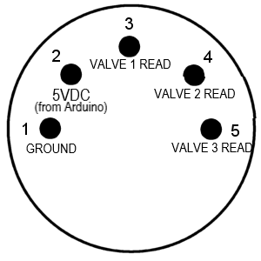

*MIDI Trumpet 5-pin DMX pinout*

Each valve button has built in LED that lights up when the instrument is properly connected to the powered Arduino.

Based on the analog read from the valve buttons, the Arduino determines whether or not a note is being played and, if played, which note is being played.

|  |  |  |  |  |  |  |  |
| --- | --- | --- | --- | --- | --- | --- | --- |
|  | **OPEN** | **1 VALVE PRESSED** | | **2 VALVES PRESSED** | | **3 VALVES PRESSED** | |
|  |  | PRESSED VALVE | OPEN VALVE | PRESSED VALVE | OPEN VALVE | PRESSED VALVE |  |
| **NO TRIGGER** | 0-2 | 0-2 | 0-2 | 0-2 | 0-2 | 0-2 |  |
| **TRIGGER 1** | 1019-1021 | 873-875 | 960-962 | 826-827 | 908-909 | 782-784 |  |
| **TRIGGER 1 & 2** | 607-608 | 532-534 | 586-590 | 512-515 | 566-567 | 496-498 |  |

*Chart of the analog read values of the analog input pins when combination of roller switches and valve buttons are pressed*

Arduino establishes serial communication with Processing, and Processing utilizes The MidiBus library to send note on/off commands to a virtual MIDI bus, from which a VST with trumpet sound can be played. Mac OS has a native virtual MIDI driver, but Windows OS requires a third-party virtual MIDI driver, such as the *loopMIDI* developed by Tobias Erichsen.

**Parts List**

The MIDI trumpet:

Main body – 1” SCH40 PVC

1” PVC coupling, socket

1” to ¾” PVC reducer bushing, spigot

¾” PVC MPT x FPT extender

1-1/2” to 1” PVC reducer bushing

2” to 1-1/2” reducer bushing

3” to 2” reducer bushing

Valve buttons - EG STARTS 5 Piece 24mm Full Color LED Illuminated Push Button Built-in Switch 5V Buttons for Arcade Joystick Games

Roller switches - WINOMO Mini Micro Limit Switch Roller Lever Arm SPDT

Communication – Neutrik NC5MDL-1 5 Pin XLR Male Panel Mount Connector

Neutrik NC5FDL-1 5 Pin XLR Female Panel Mount Connector

Accu-Cable AC5PDMX10 10' DMX 5-pin Cable

Arduino Uno R3

**Build Process**

The initial step was to write the Arduino and Processing sketch, mainly to ensure that The MidiBus library on Processing was capable enough for the project. After calculating the values of resistors needed and drawing the schematic, a breadboard setup with the roller switches and arcade buttons was constructed.

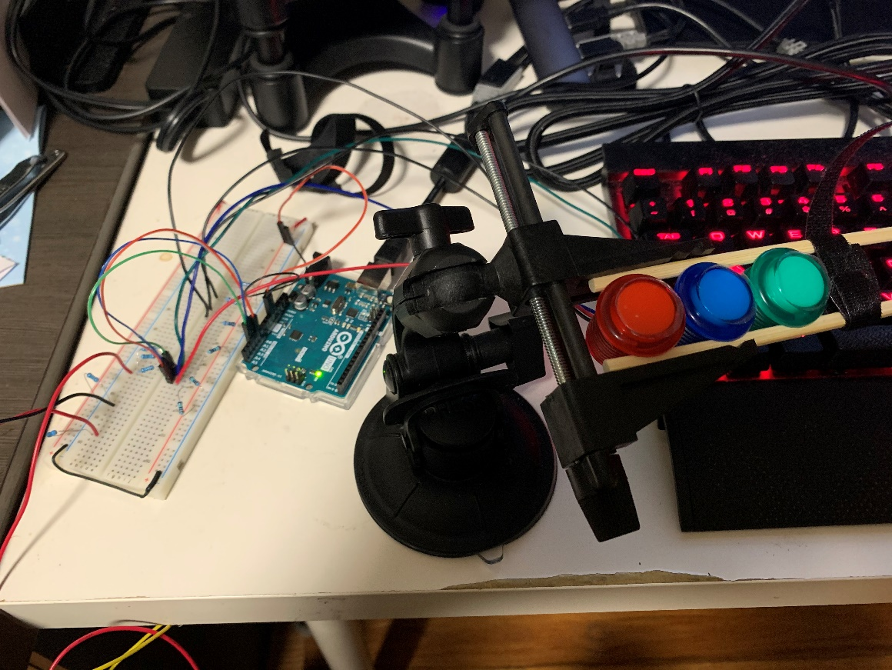

*Initial breadboard build*

The setup was tested using an online virtual VST, *Virtual Piano* by Recursive Arts <<https://recursivearts.com/virtual-piano/>>, to ensure MIDI notes can be played.

Next step was to ensure the roller switches can successfully be activated by inflating a plastic bag. Roller switches were installed in PVC by tapping the mounting holes and using #6-32 machine screws. A plastic grocery bag was cut and taped together. The roller switch hinges were slightly bent to control how easily the inflating bag activates the switch.

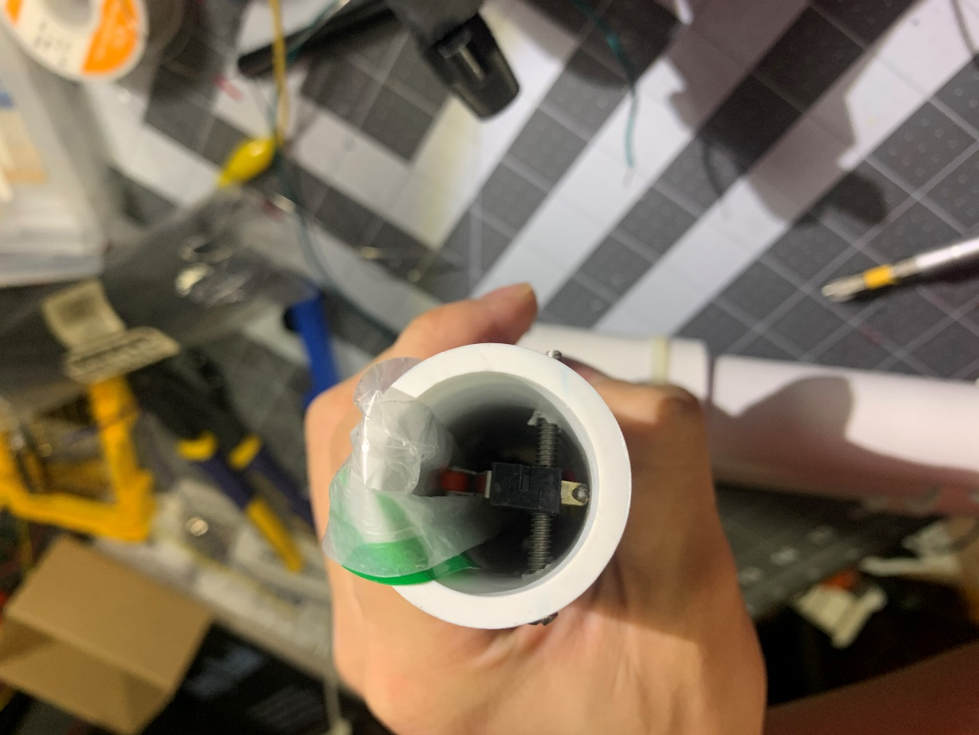

*Roller switch installed with plastic bag*

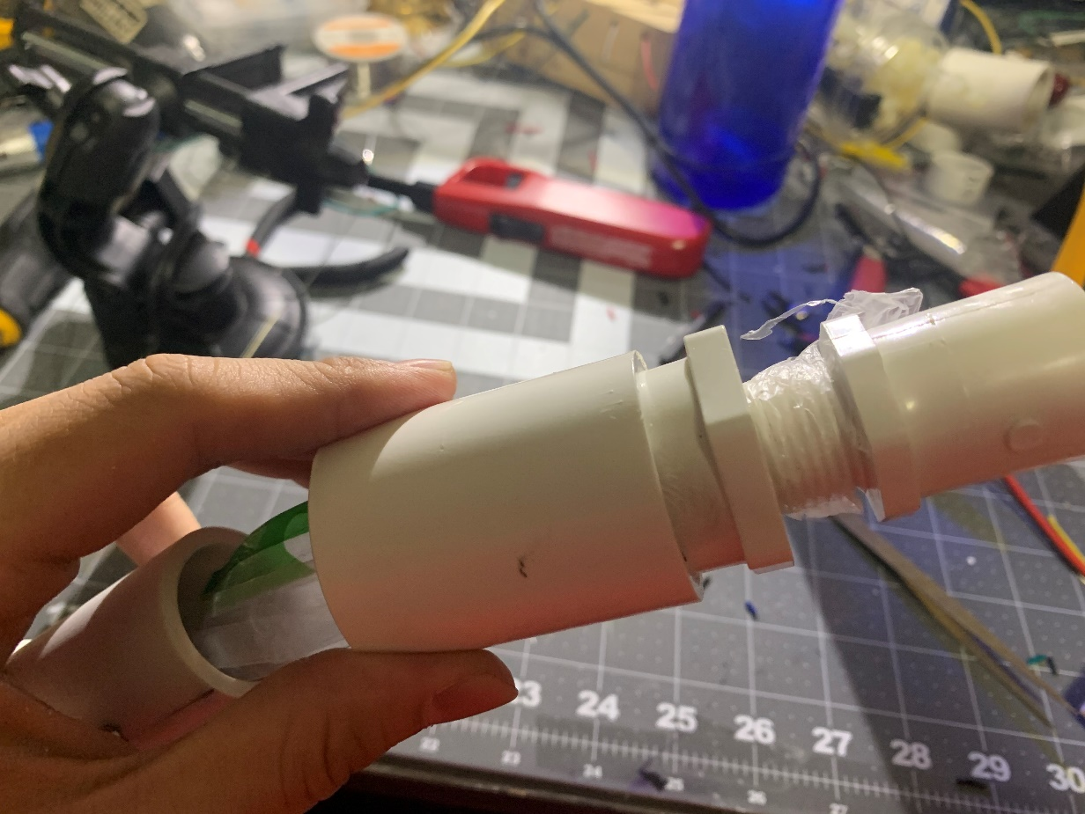

*Plastic bag secured by screwing the ¾” spigot extender, which is the mouthpiece*

PVC parts were cut, and the body construction of the trumpet was then complete, ready for the internal components to be installed.

Resistors were installed by soldering wires on both sides and thermal sleeve applied over it. Important note in doing this is to make sure the wires do not bend where the resistors are installed, otherwise the legs of resistors can snap from the body.

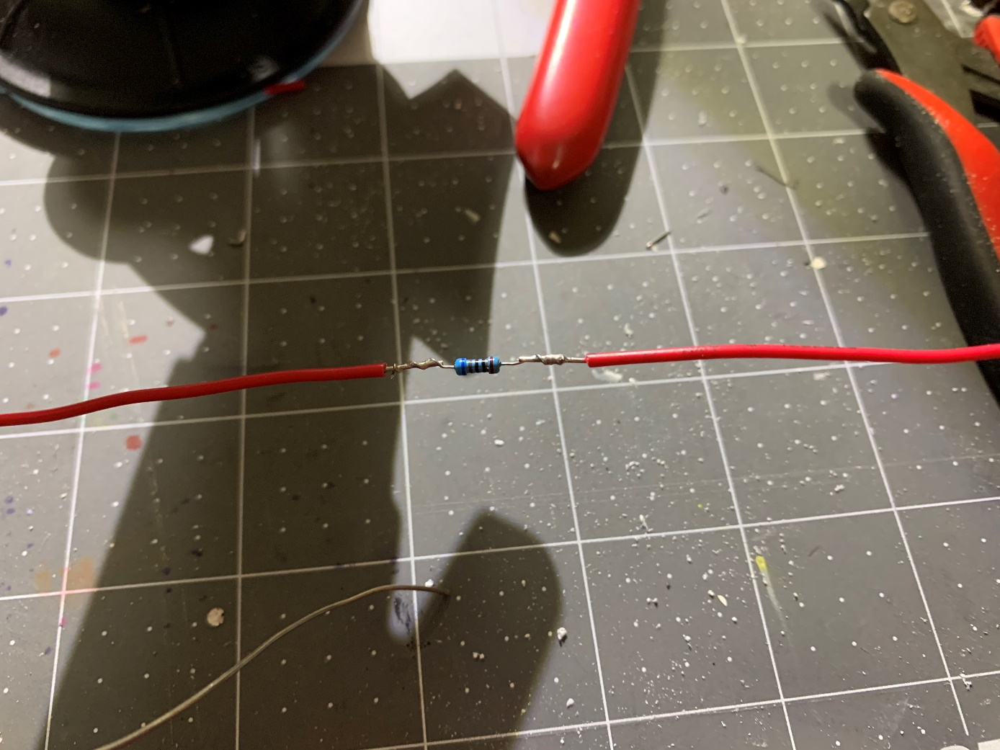

*Resistors soldered in line with the wire*

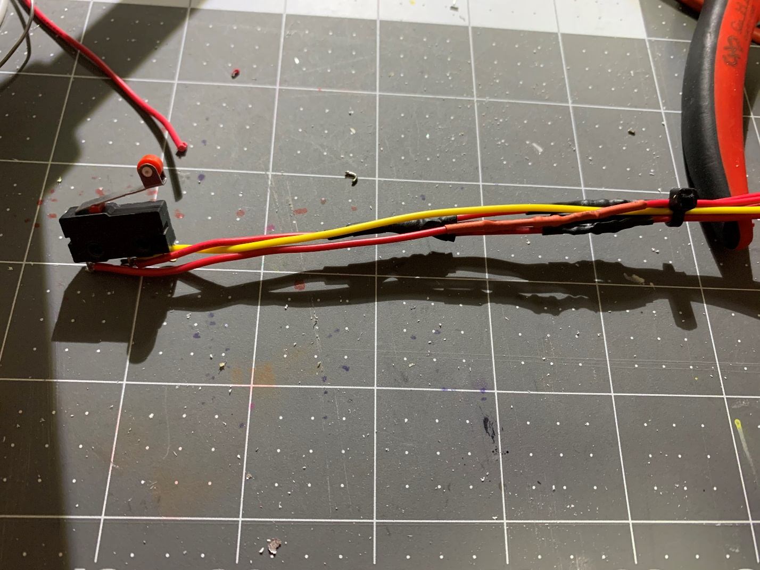

*Roller switch with wires and resistors soldered*

The mounting nut for the arcade buttons were epoxy glued to 1” PVC, so that the arcade buttons can be easily screw-mounted.

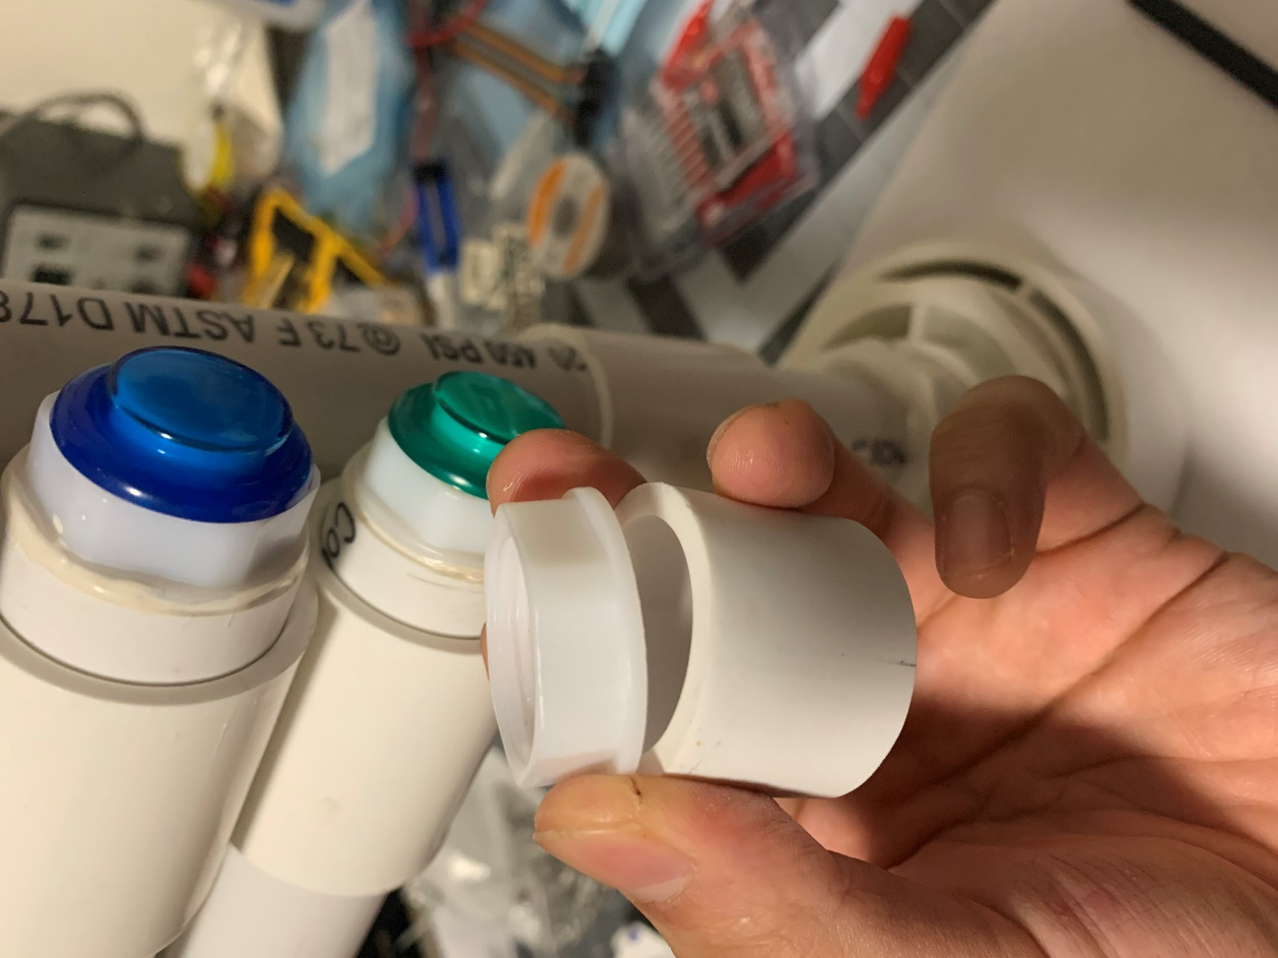

*Arcade button mounting nut epoxy glued onto 1” PVC*

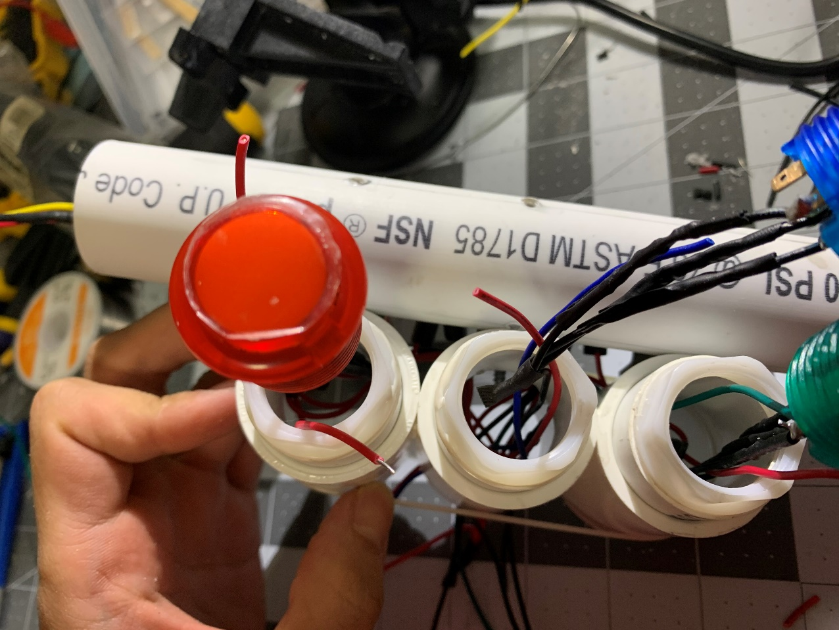

*Arcade buttons can be easily screw-mounted after soldering the wires*

The wires from the lead pipe feed into the valves, and soldered to the arcade buttons.

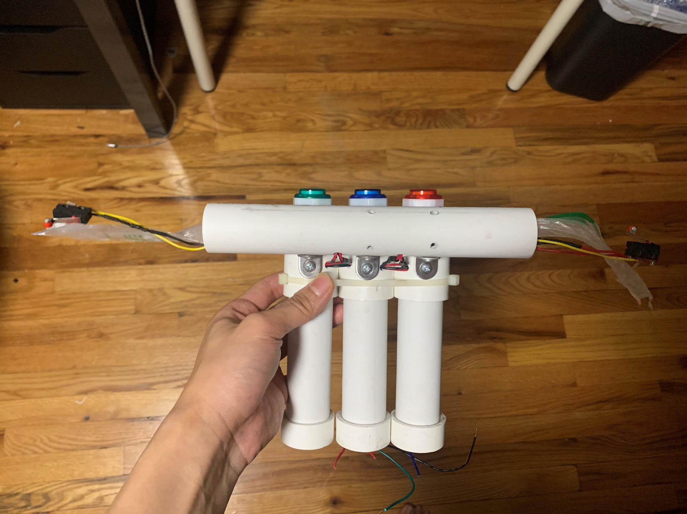

*Wires from lead pipe feed into the valves*

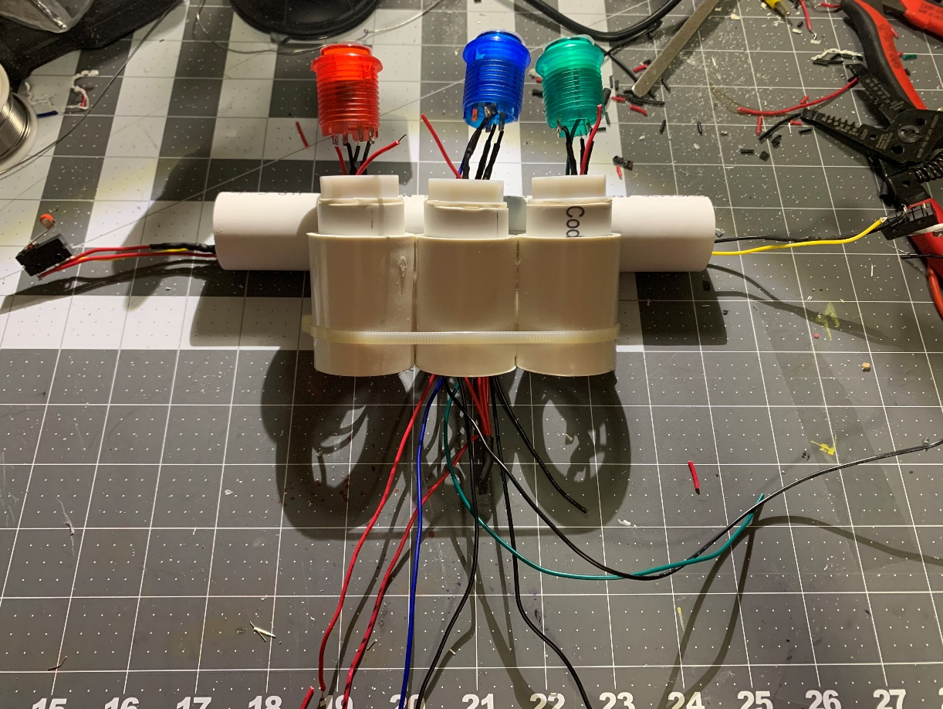

*Wires connected in the valve pipes*

After ensuring the switches were soldered correctly, the wire leads coming out of the bottom connected to the 5-pin connector.

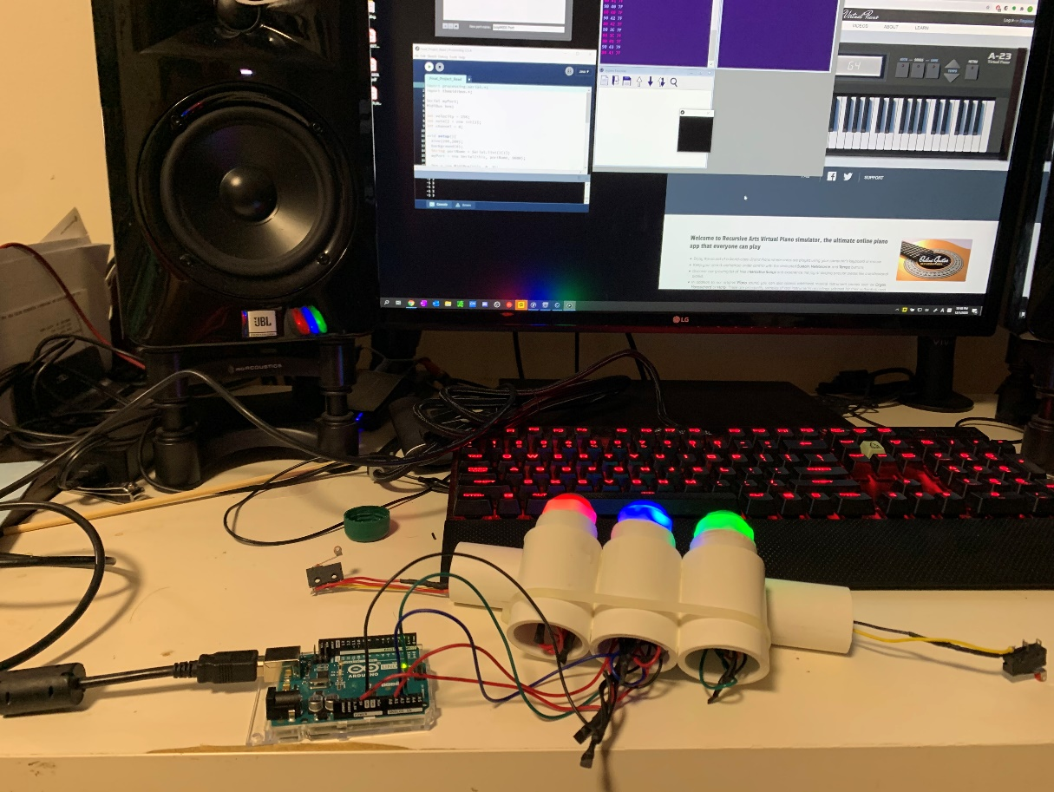

*Testing to ensure switches soldered correctly*

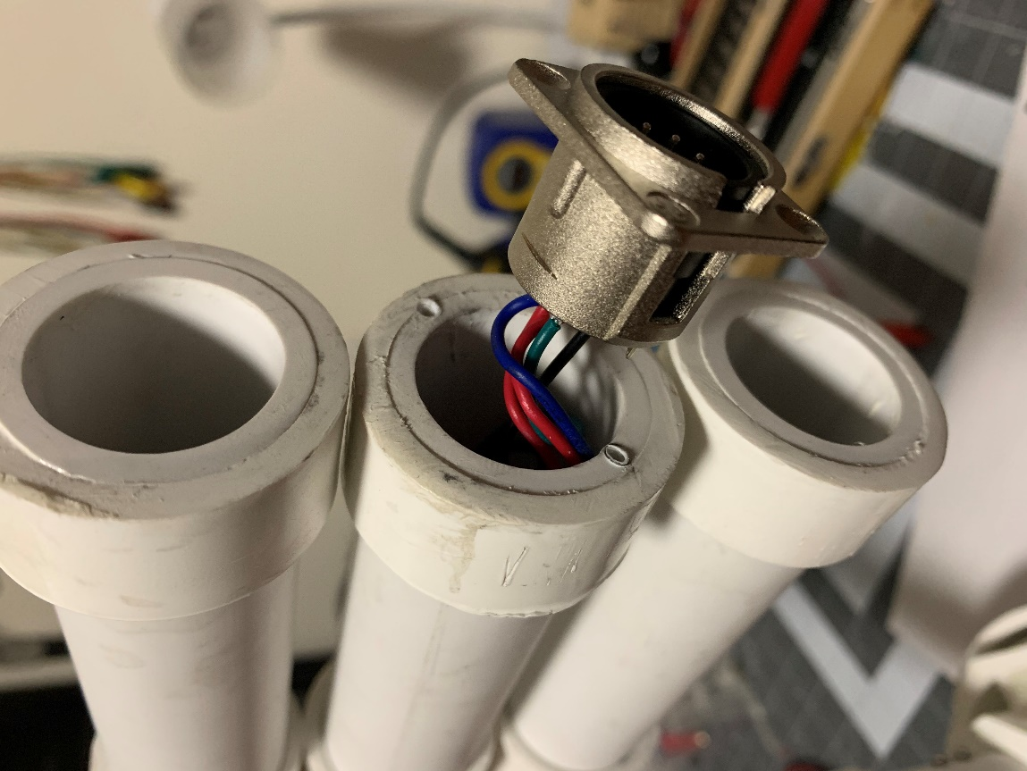

*Wire leads soldered to the 5-pin connector on the bottom of second valve*

The Arduino and the female 5-pin connector were housed in a cardboard box with holes cut out for the ports.

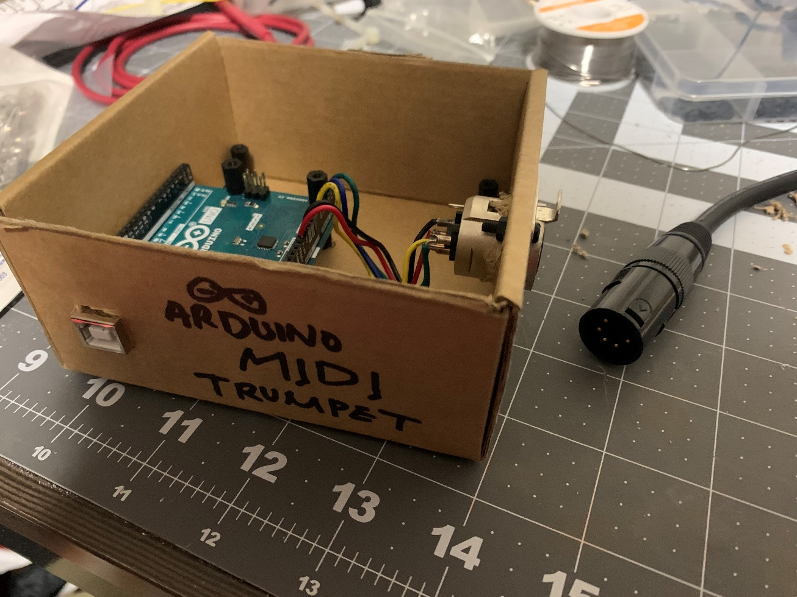

*The “Arduino box” connects to the 5-pin DMX from the trumpet and USB to computer*

**Conclusion**

Video overview and playing the MIDI trumpet: <https://vimeo.com/490040935>

The Arduino MIDI trumpet, in its most basic purposes, works very well to produce MIDI notes based on the amount of air that is breathed into the instrument.

Currently, there is a 60ms retrigger delay between the reading of the notes to decrease the sensitivity between switching notes. Without the retrigger delay, any less than exactly precise note switching introduces unwanted notes in-between.

The 11-note range is the most disappointing feature, and in order to increase the trumpet’s range, more roller switches would have to be installed. Although seemingly possible, the sensitivity of breath control required to freely activate more than two roller switches would seem much too difficult for practical use.

In order to effectively improve the instrument capabilities, I imagine that Processing would be taken out of the equation. The byte size serial communication limits any complex MIDI commands beyond note on/ note off. In order to increase the note range and introduce more sensitive commands, such as velocity and pitch bend, just using the Arduino without serial communication to Processing, I believe, would be more powerful. I imagine replacing the roller switch idea with a pressure sensor chip, such as the MPXV4006GP, and let Arduino transmit MIDI commands directly.

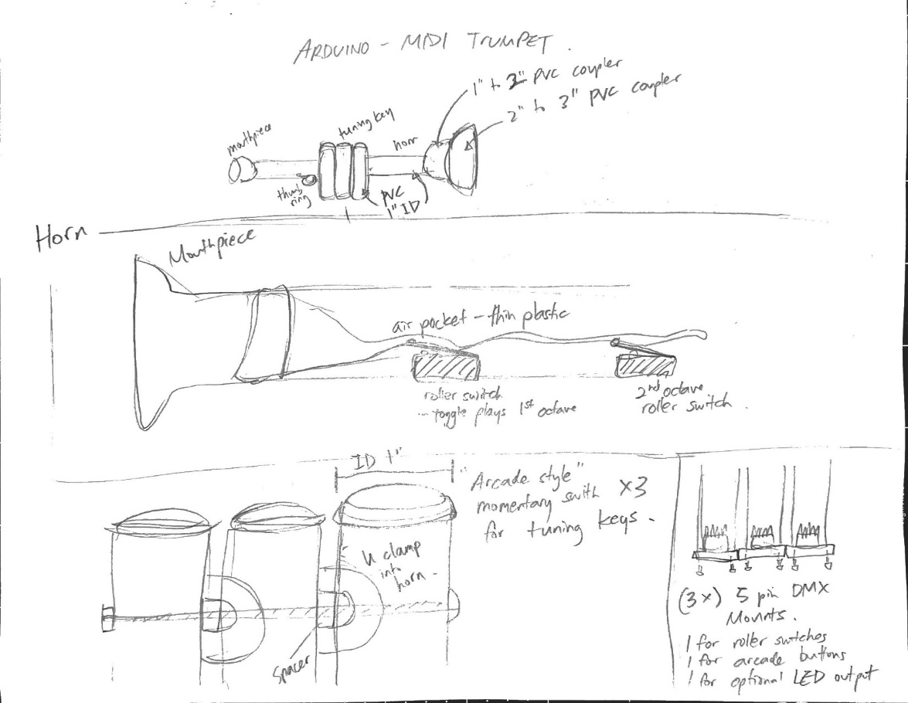

*Appendix A - MIDI trumpet initial drawing*

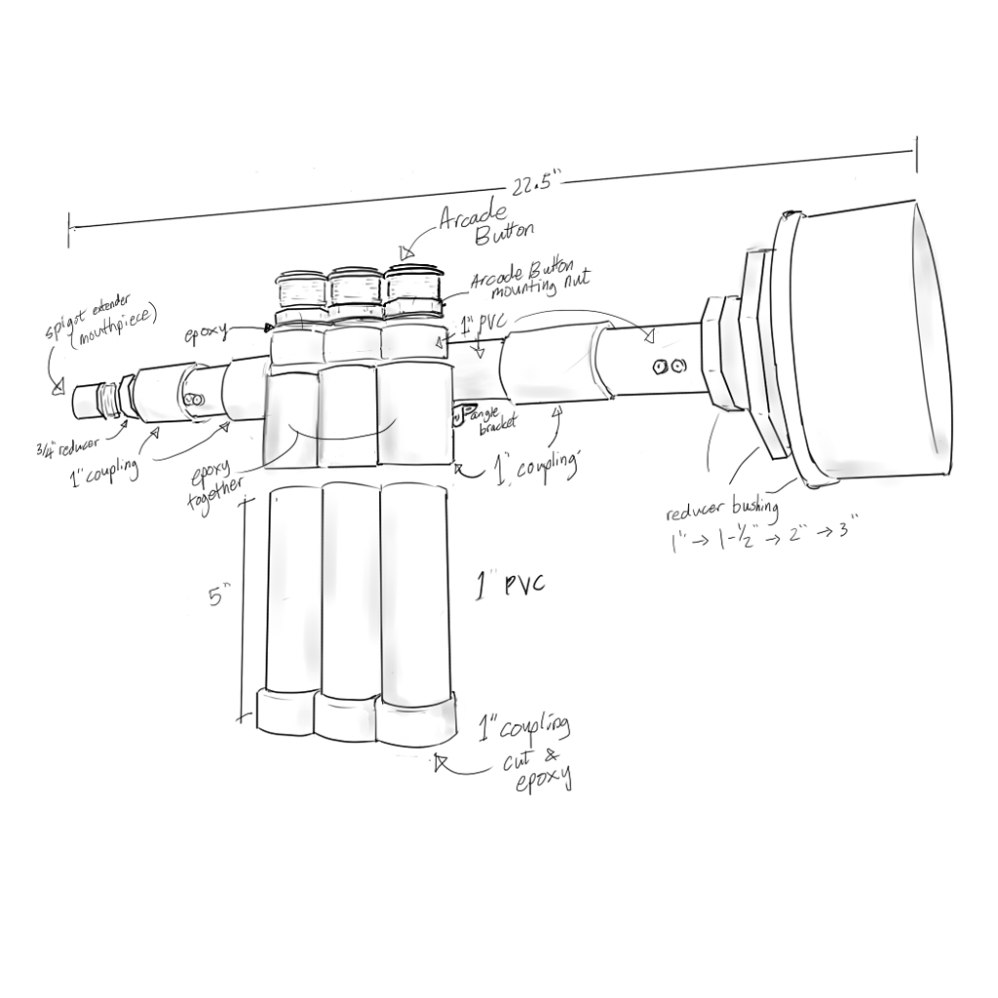

*Appendix B - MIDI trumpet model drawing*

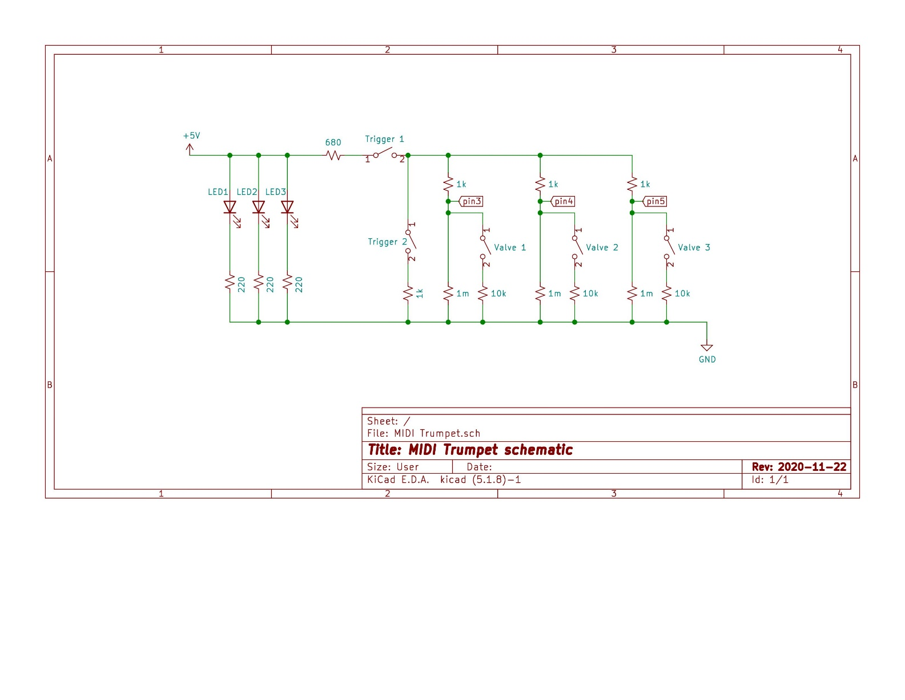

*Appendix C - MIDI trumpet schematic*

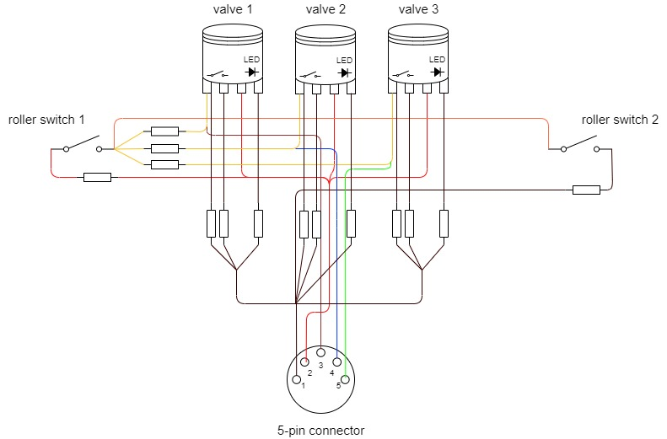

*Appendix D – MIDI trumpet wiring diagram*